Assignment 3
Please turn in all parts of the assignment on a single word document
Assignment 3A:
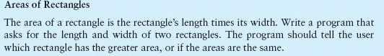
Assignment 3B:
Modify your Assignment 2C as described bellow:
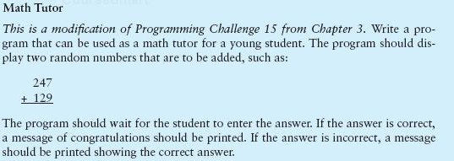
Assignment 3C:
